https://isss608-ay2021-22t2.netlify.app/dataviz/dataviz1

Ctiric the four quadrant, lesson 2

-the part of critic must be changed.

-graph in static form, no interactivity

-don’t replace the original data visualization totally

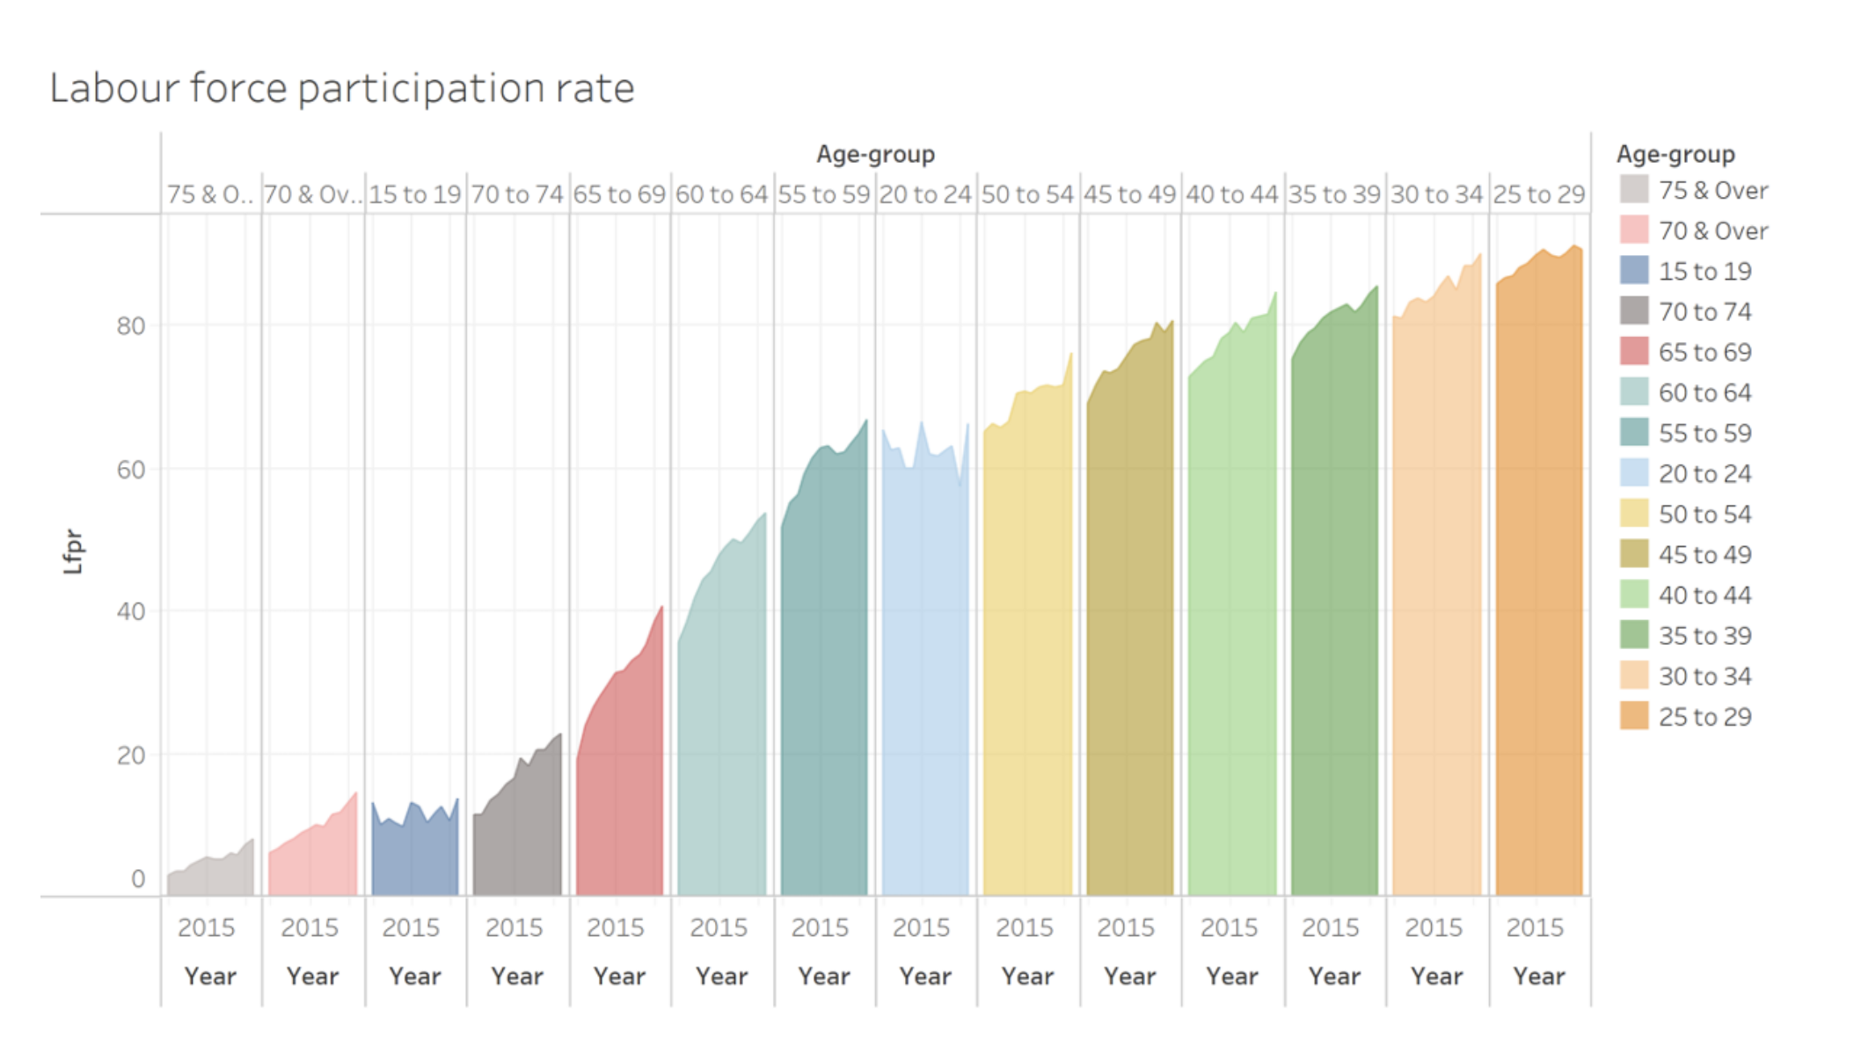

-need to know how to create this

Sketch: -highlight things you want to do and notes on the side.

-each worksheet: one data visualisation

-use data prep from tableau.

-don’t use tooltip, use annotations

2015-2021

https://dylanwong.netlify.app/posts/2021-01-26-dataviz-makeover-1/

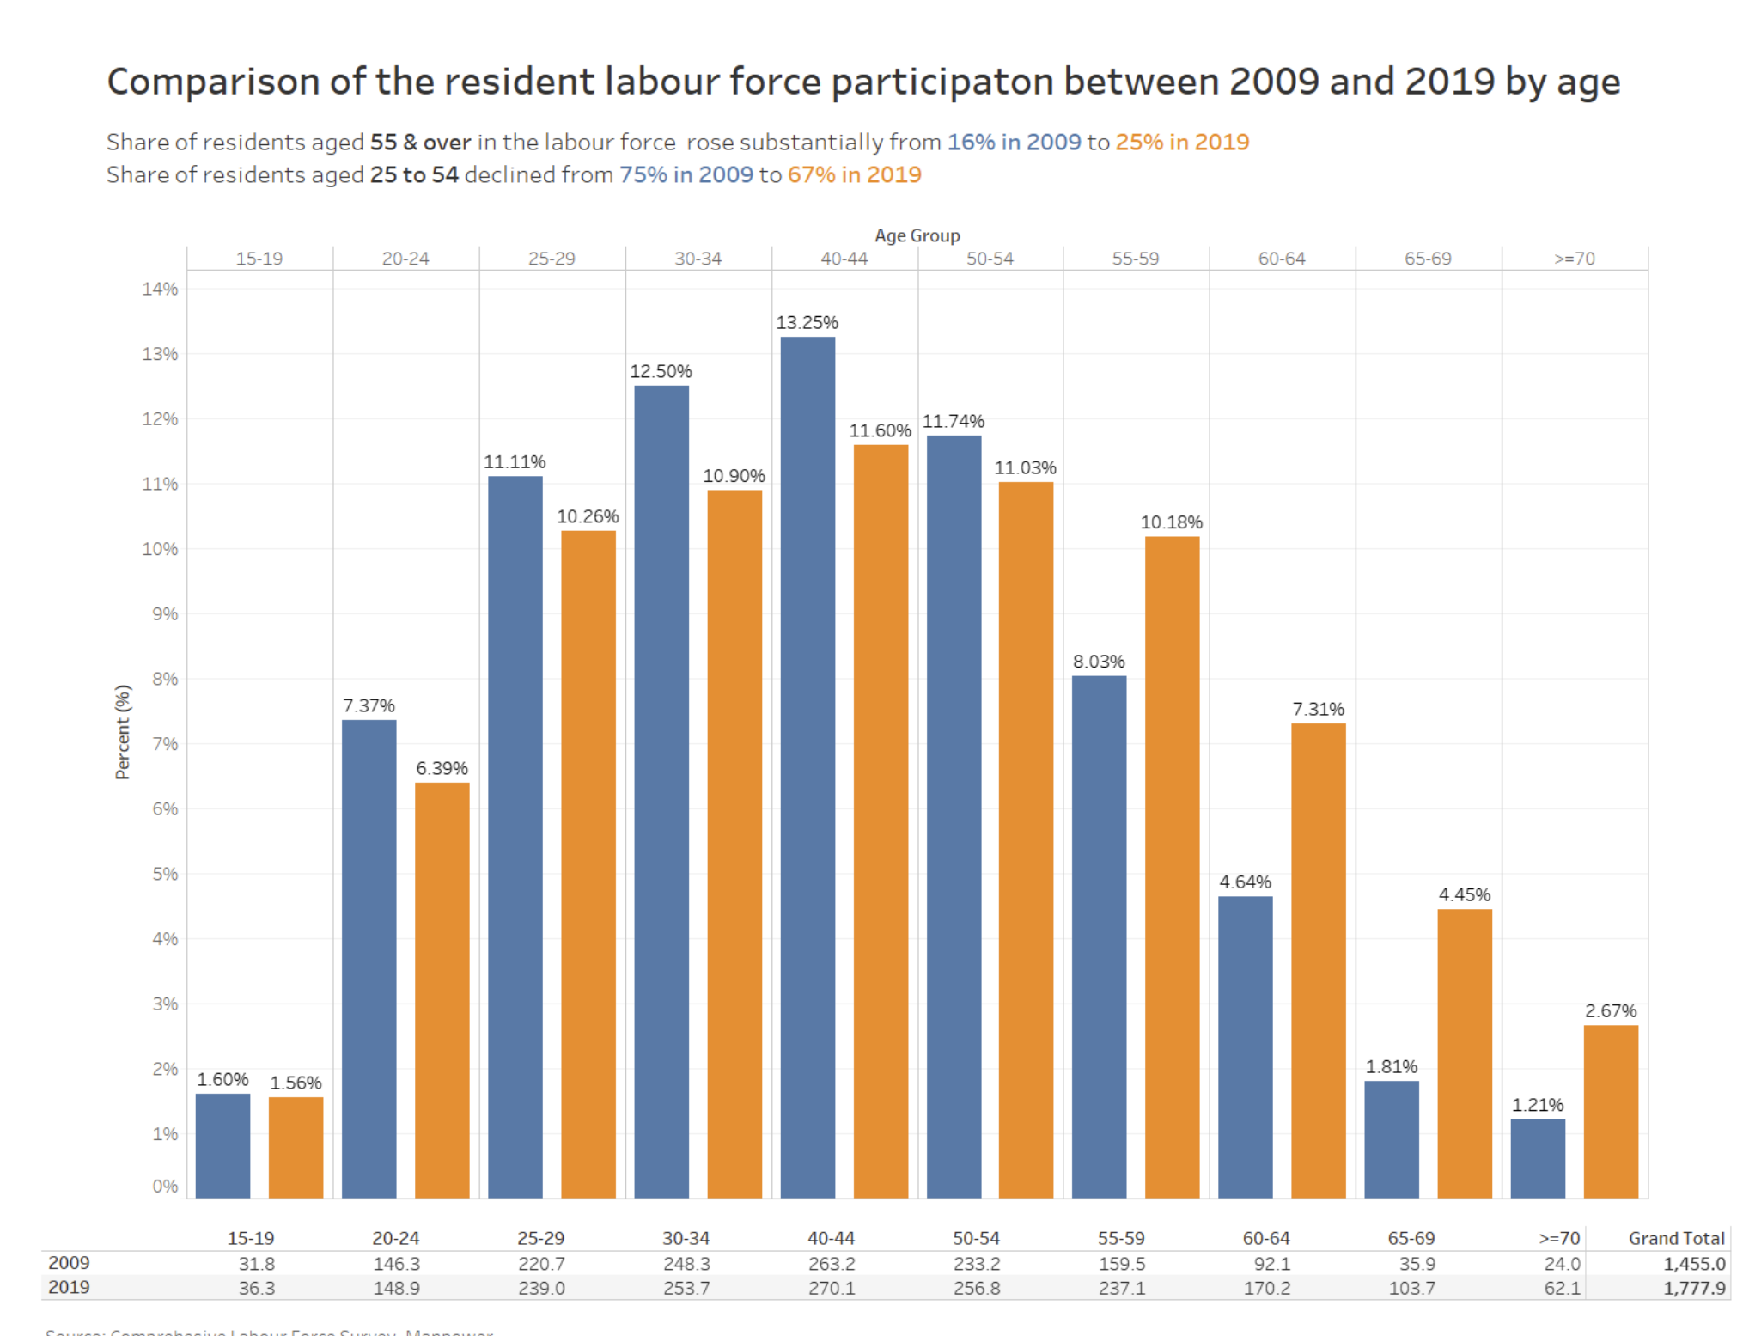

<https://andywong.netlify.app/posts/dataviz-makeover-1/>

data preparation using tableau

-critic using 4quadrants

<https://jason-tey.netlify.app/posts/2021-01-23-dataviz-makeover-1/>

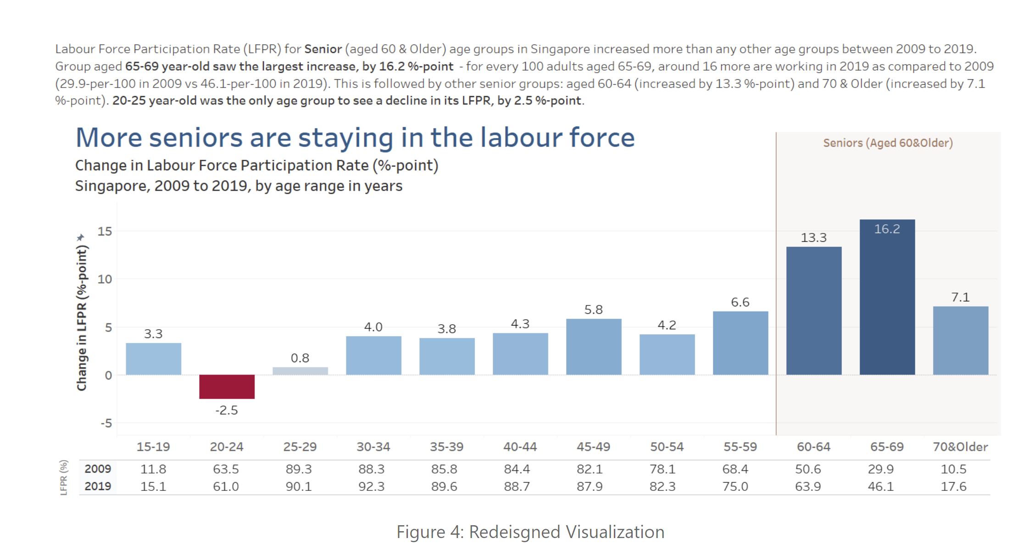

-percentage change?

<https://louelle.netlify.app/posts/2021-01-23-dataviz-makeover-assignment-1/>

-video presentation of the process]

<https://serene-bhabha-6c7d16.netlify.app/posts/dataviz/>

https://boring-goldstine-257339.netlify.app/posts/2021-01-23-dataviz-makeover-1/

-data cleaning

https://jihunnam-blog.netlify.app/posts/2021-01-20-assignment1/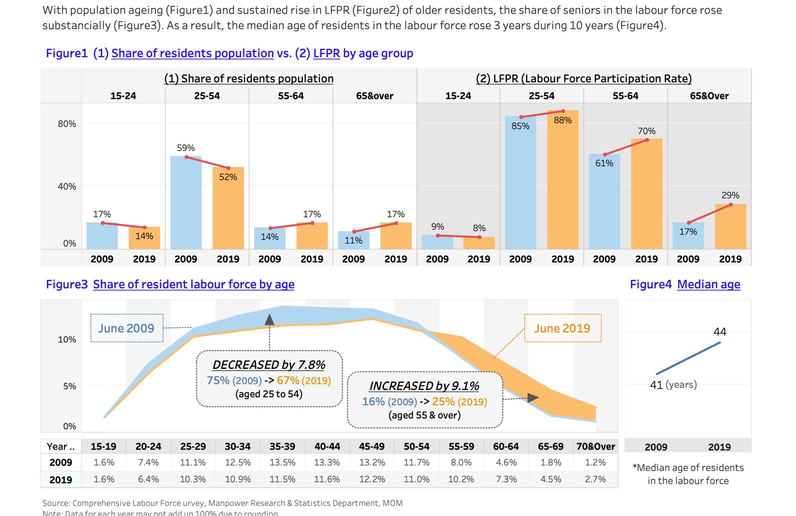

https://kaichinlim.netlify.app/posts/2021-01-24-dataviz-makeover-1/

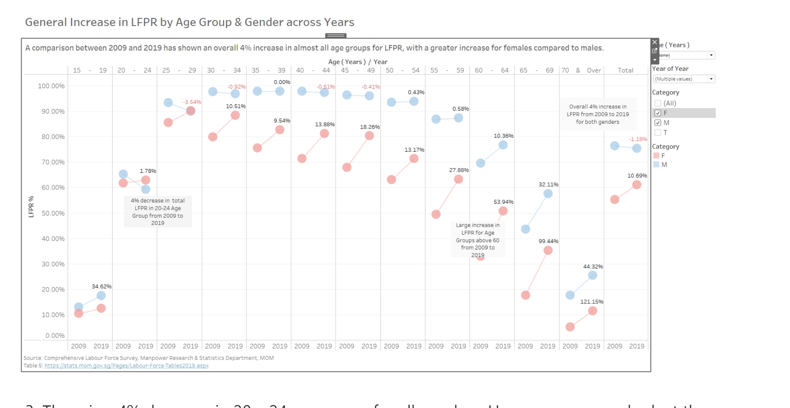

https://lizhenglong.netlify.app/posts/2021-01-27-dataviz-makeover-1/

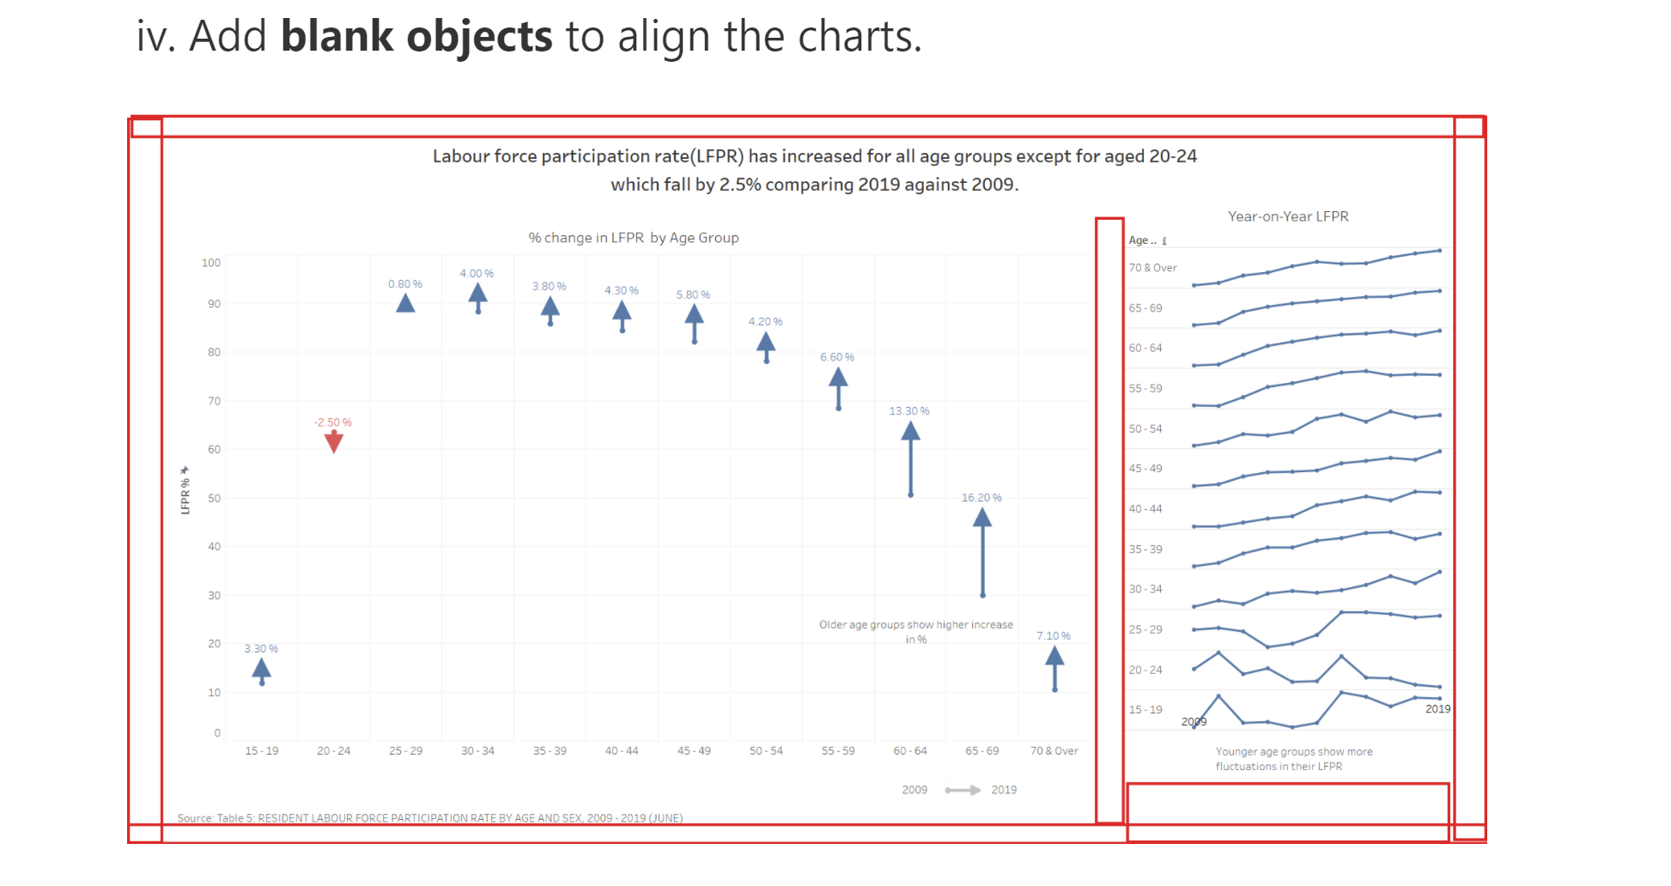

https://kgalbindo.netlify.app/posts/2021-01-24-visual-makeover-1/

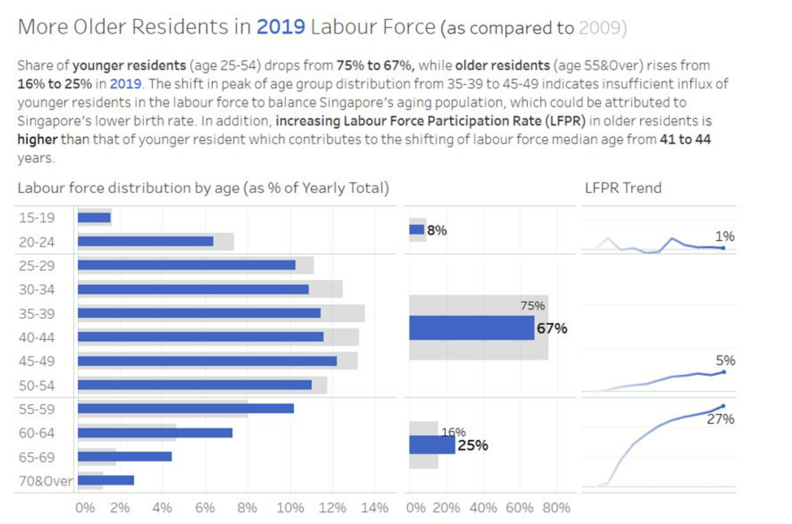

https://atticusfoo.netlify.app/posts/2021-01-20-dataviz-makeover-1/

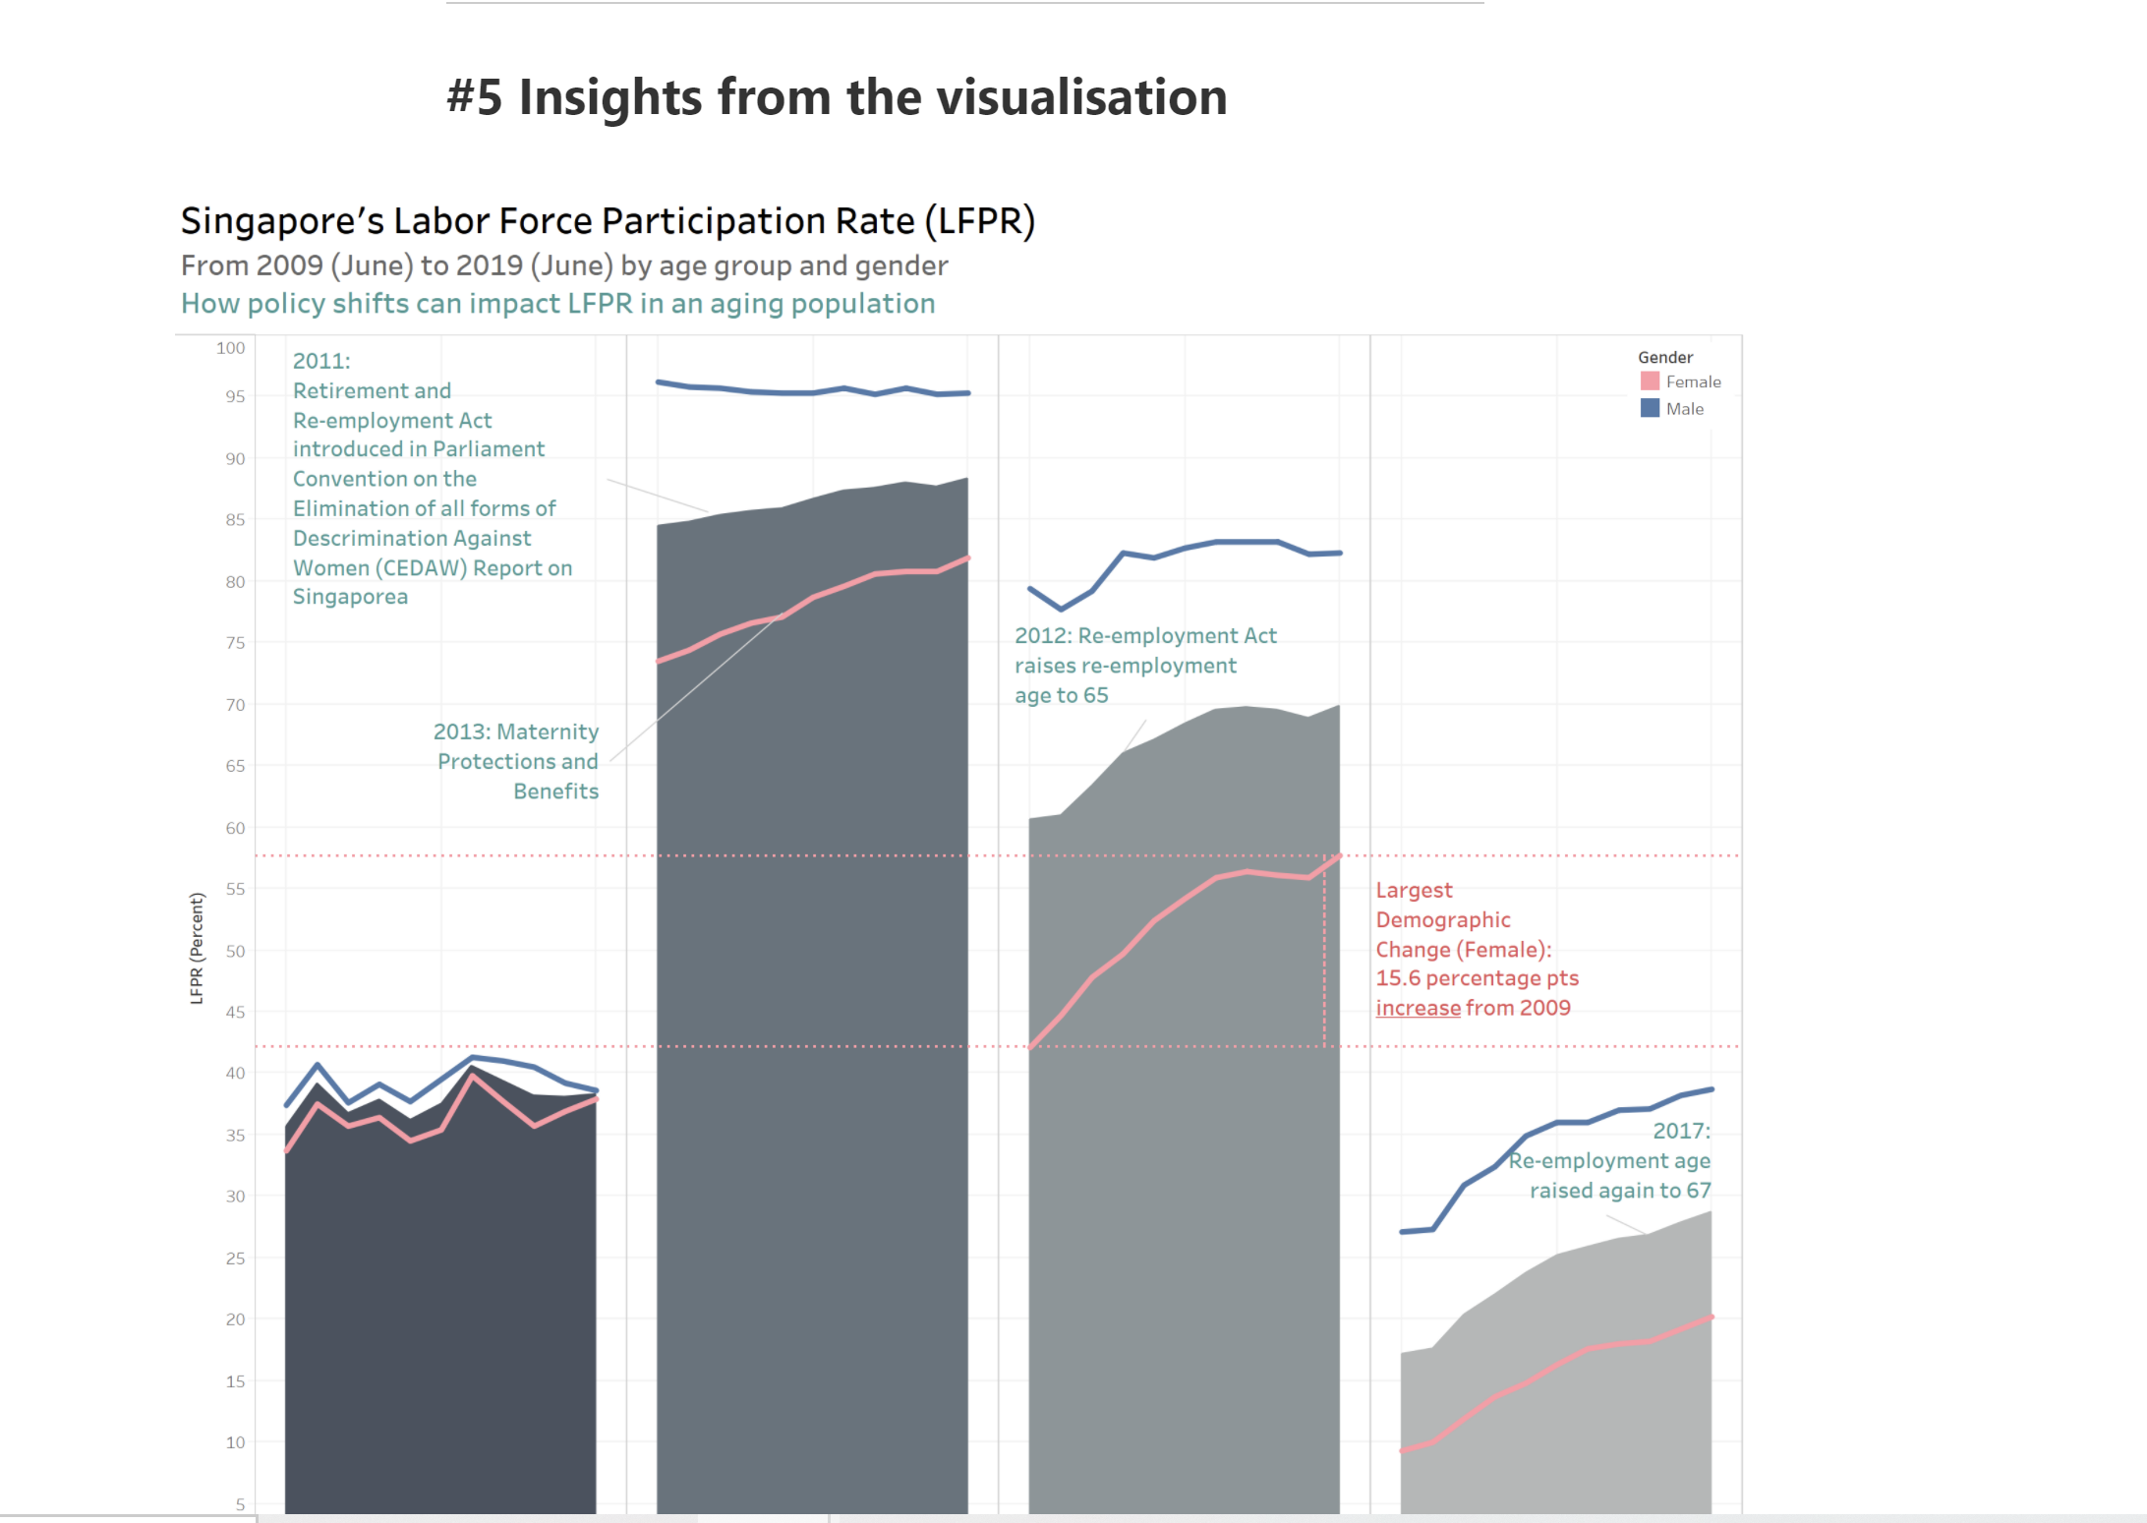

https://elaine-lee.netlify.app/posts/2021-01-27-dataviz-makeover-1/

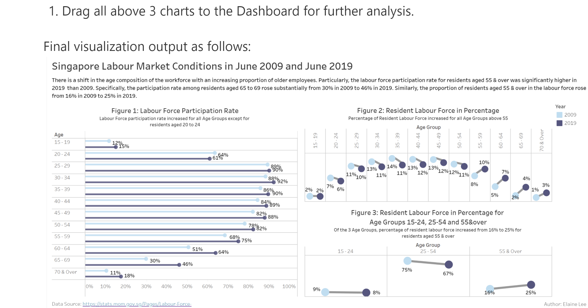

https://joeychua.netlify.app/posts/2021-01-25-dataviz-makeover-1/

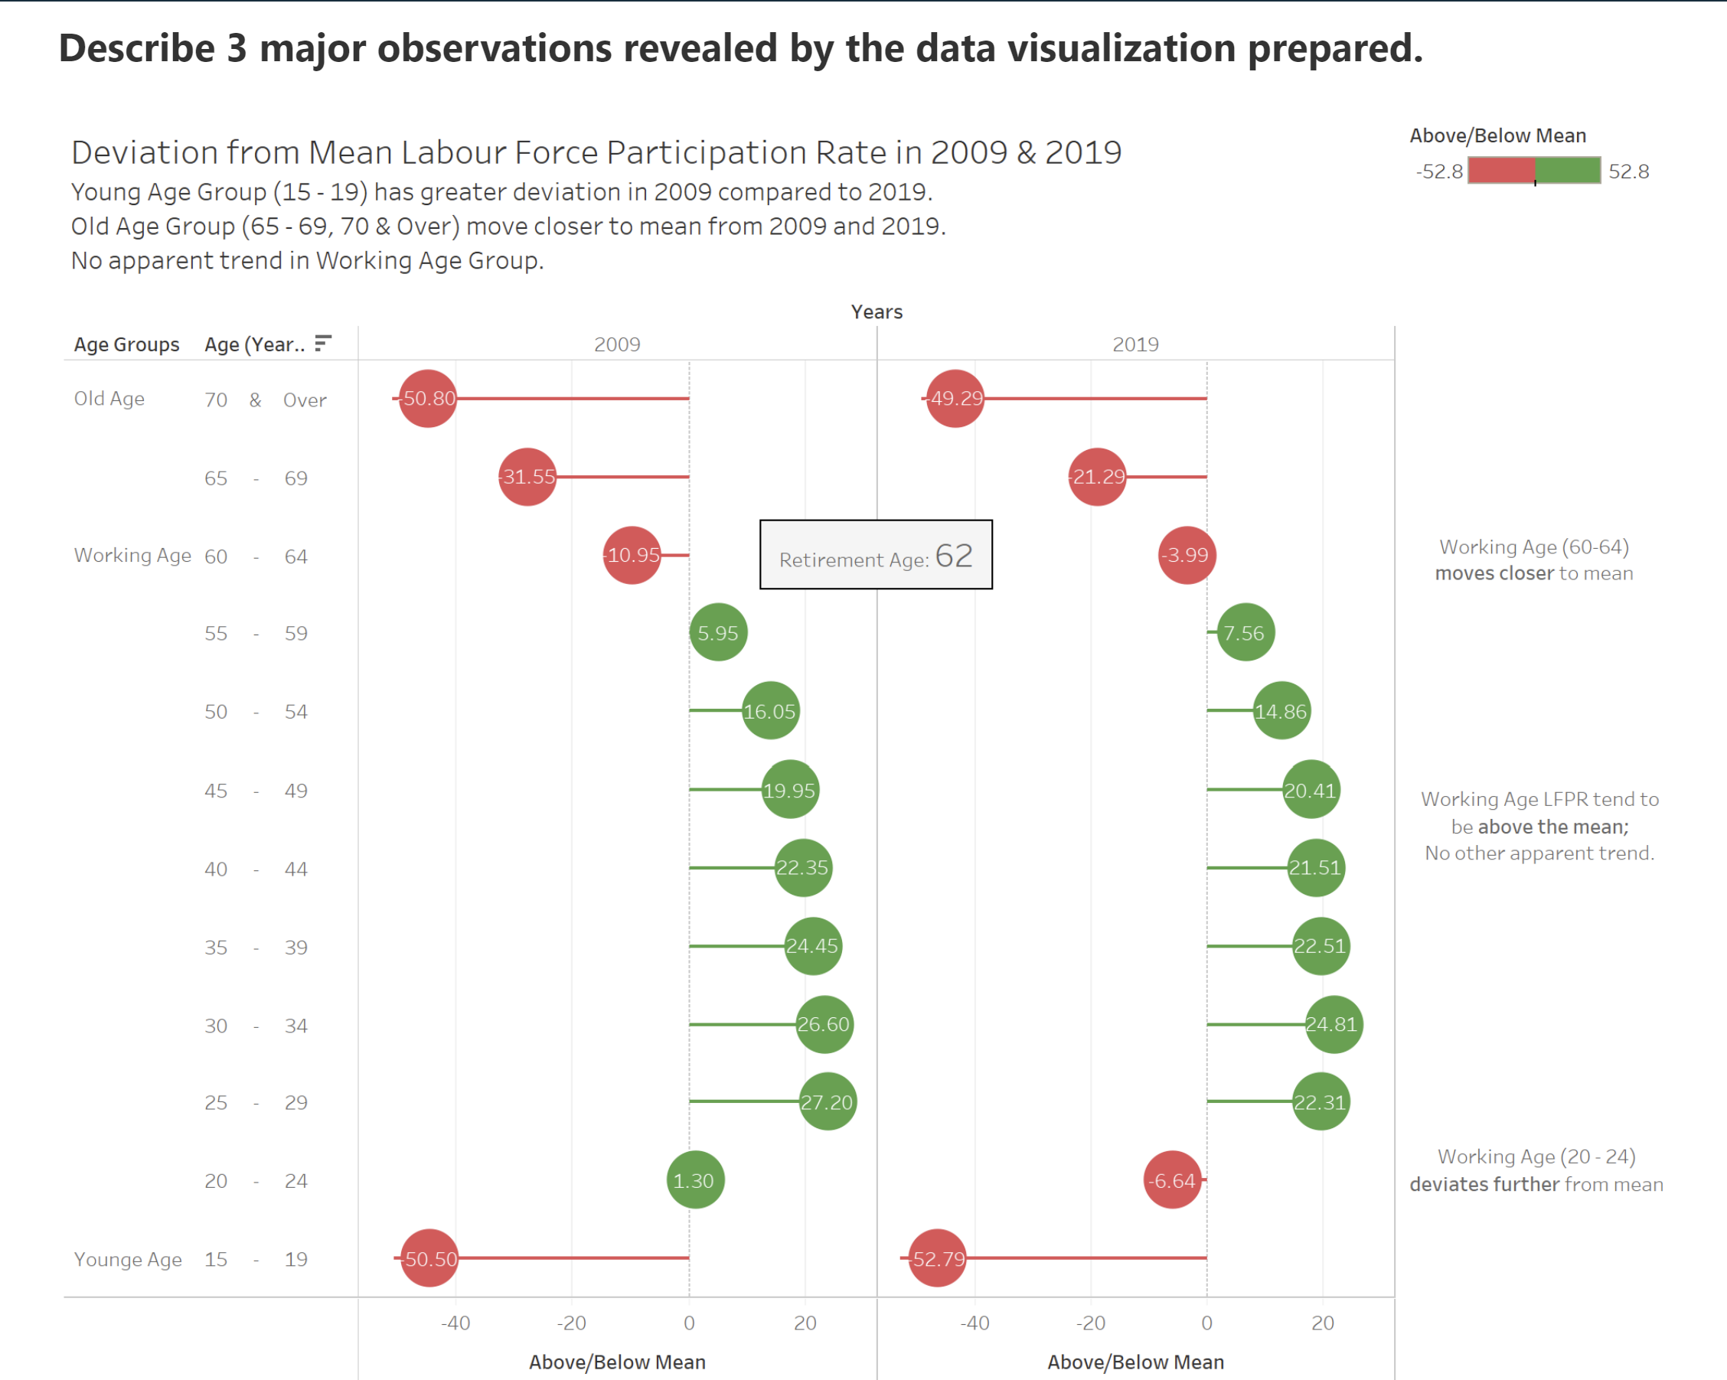

https://suyiinang.netlify.app/posts/dataviz_makeover/01_makeover/#22-aesthetics

layout

From the excel data, it can be observed that the data in ‘mrsd_Res_LFPR_2’ sheet contains labor force participation rate for total, males and females. For ease of analysis, will put these three parts into three sheets.

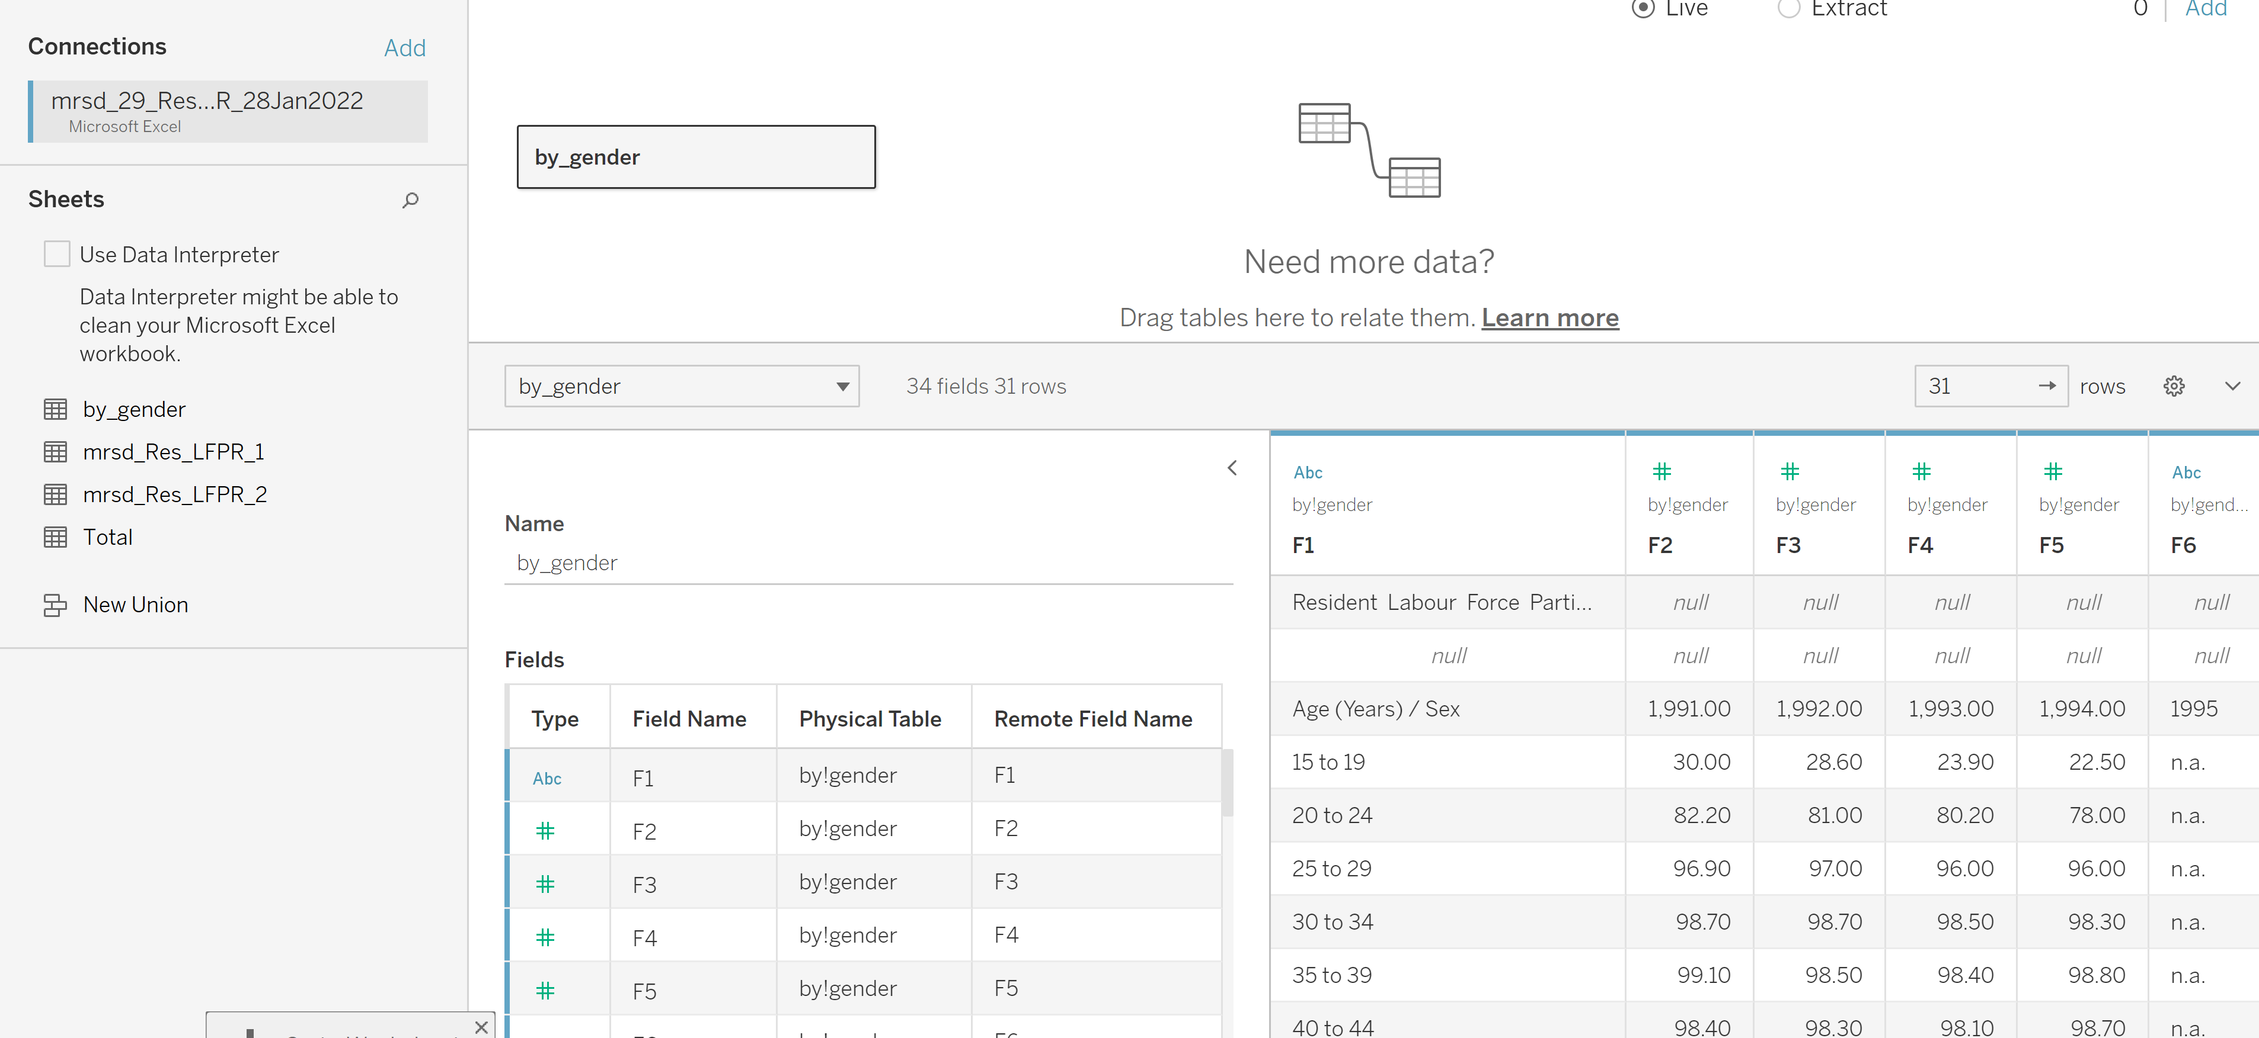

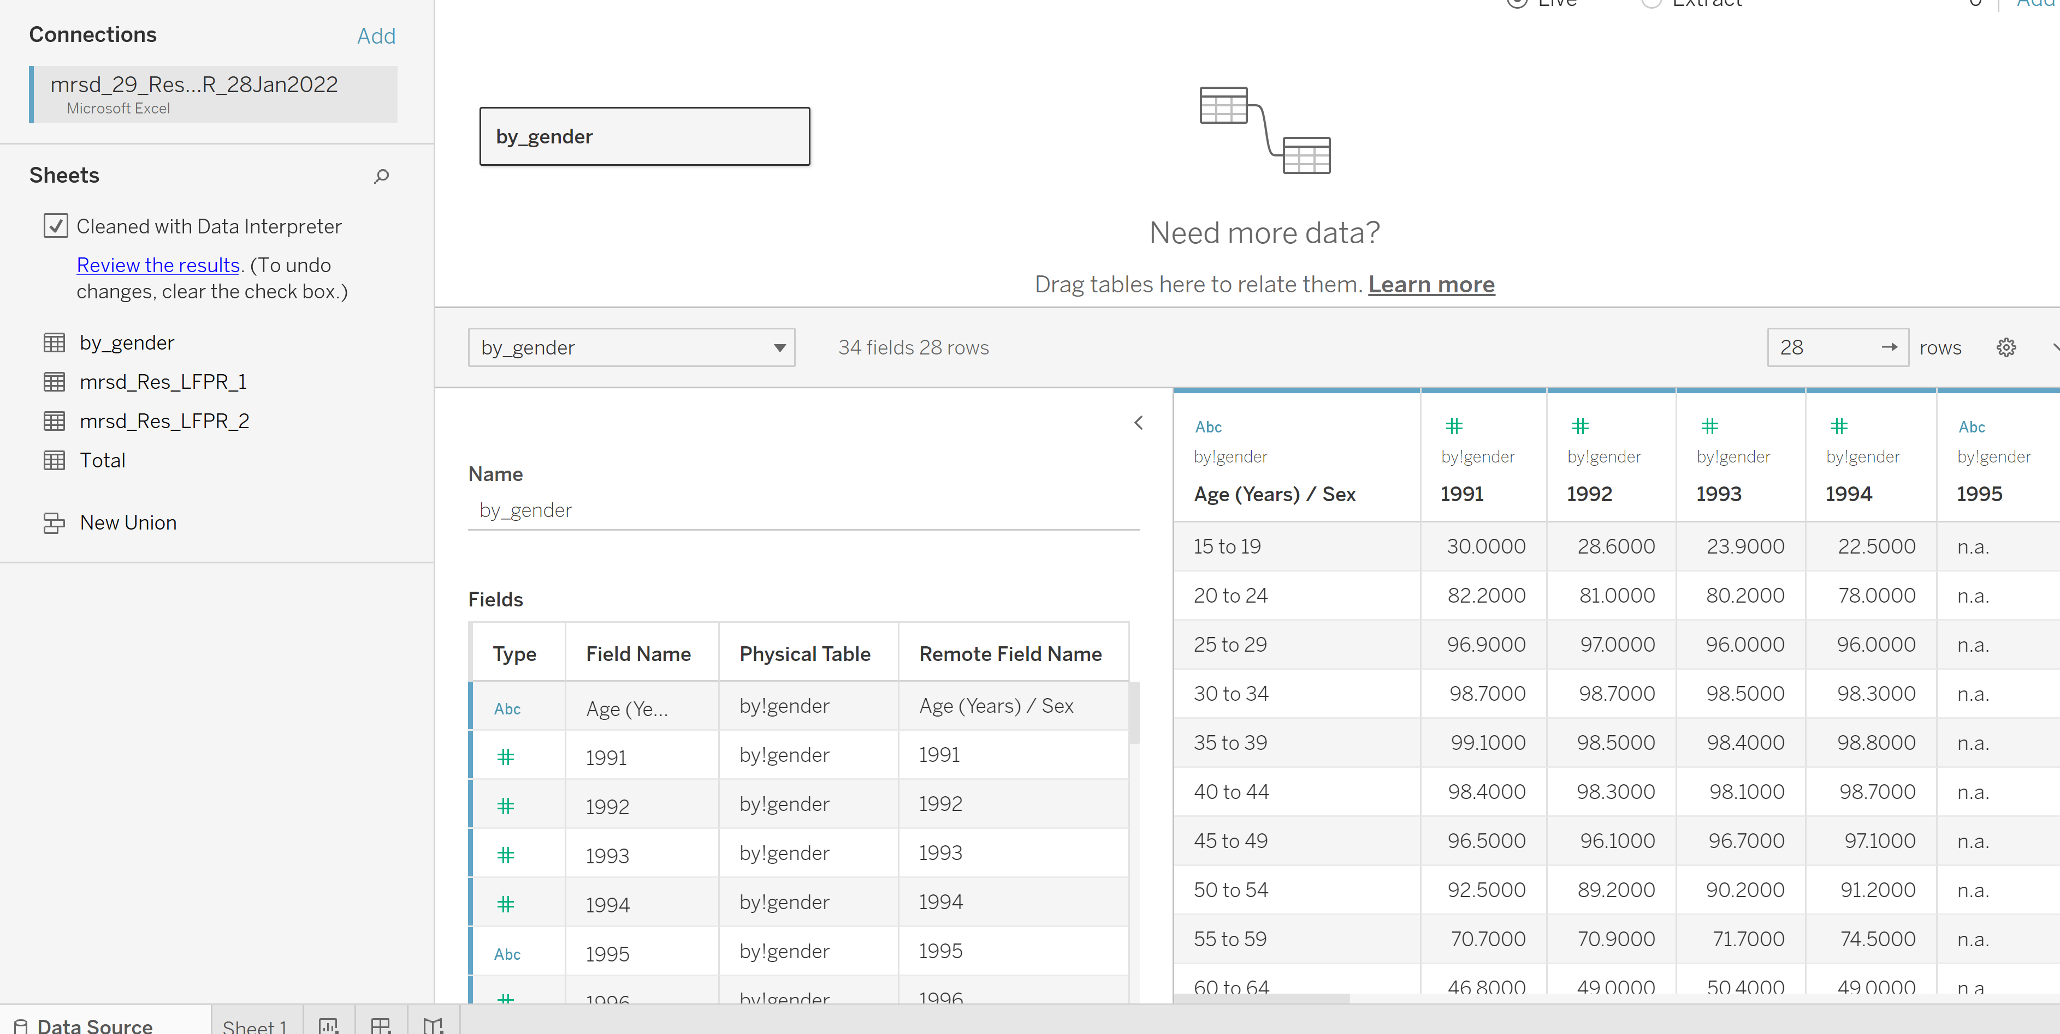

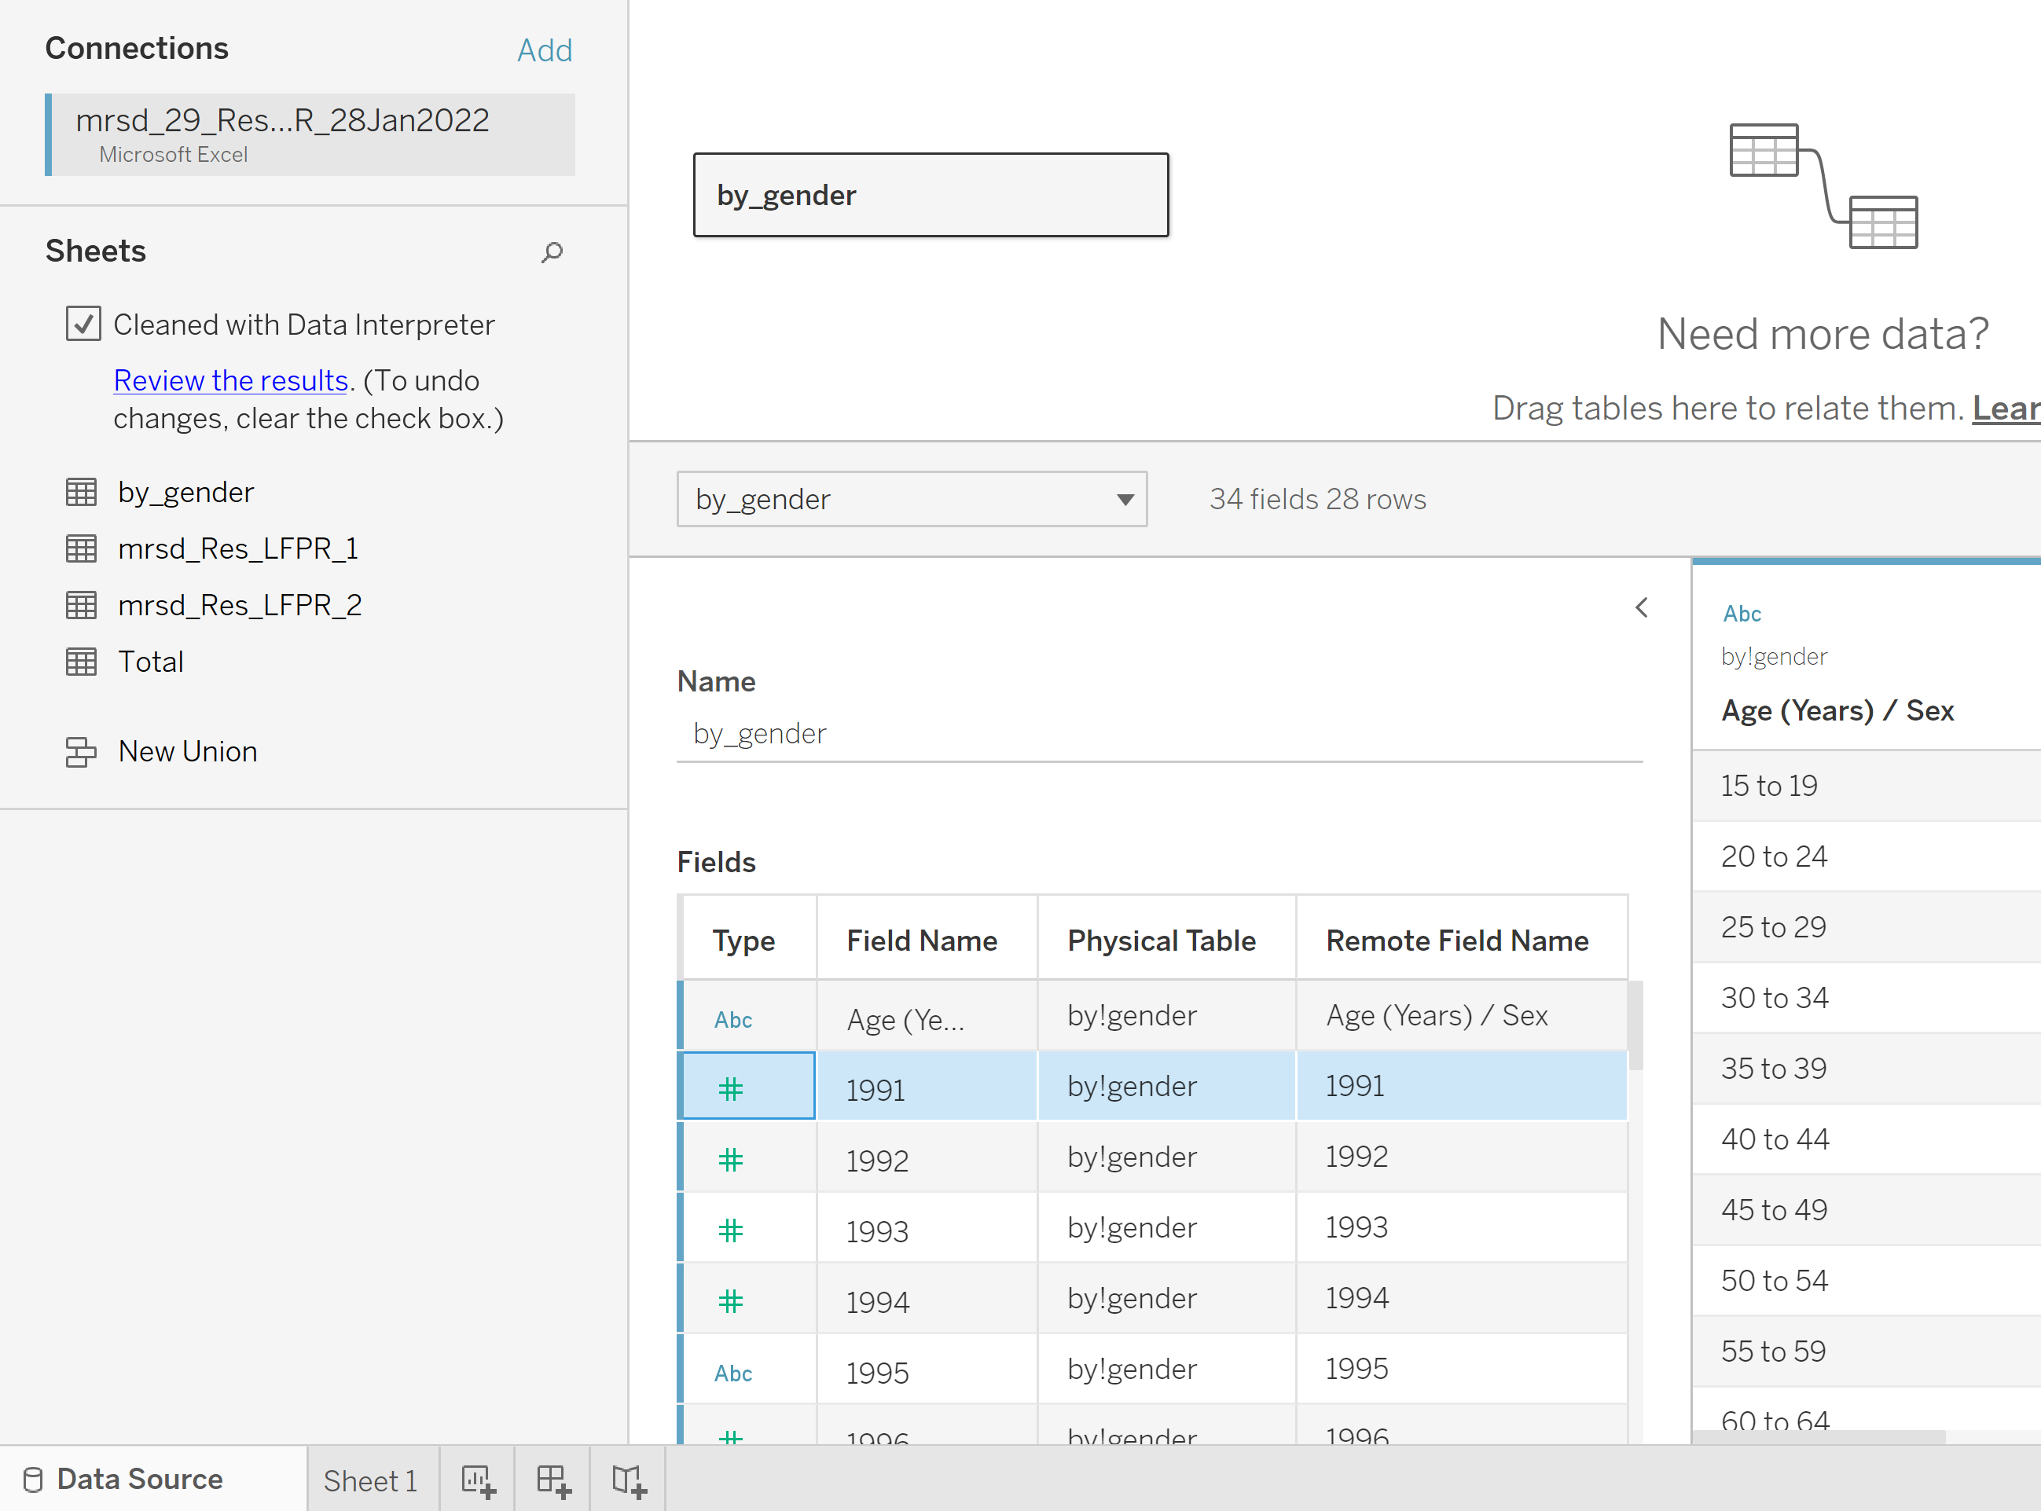

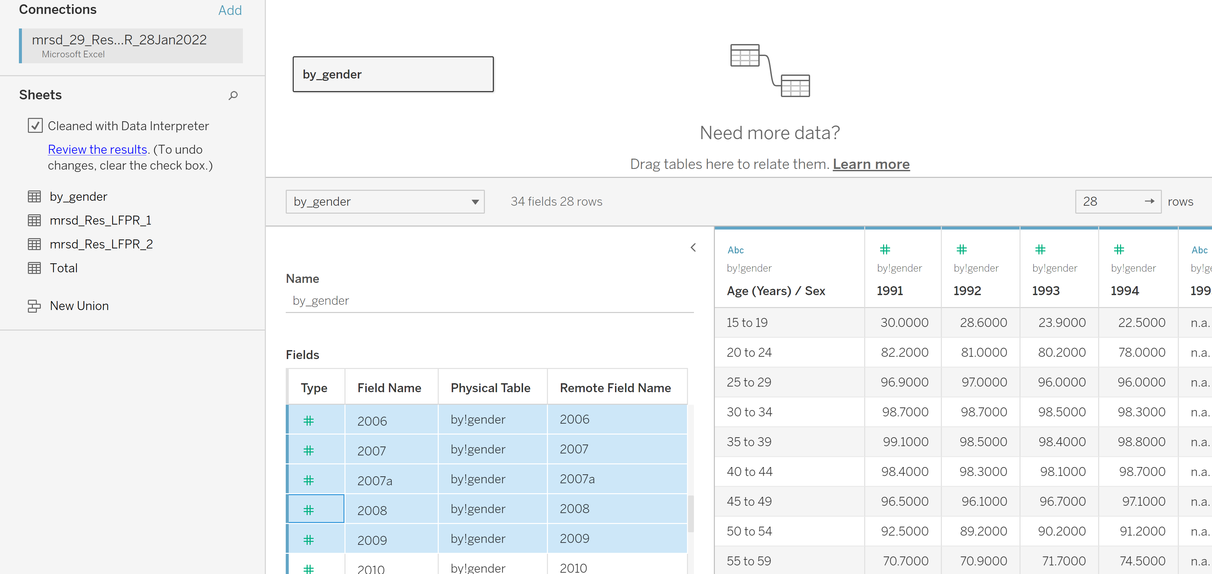

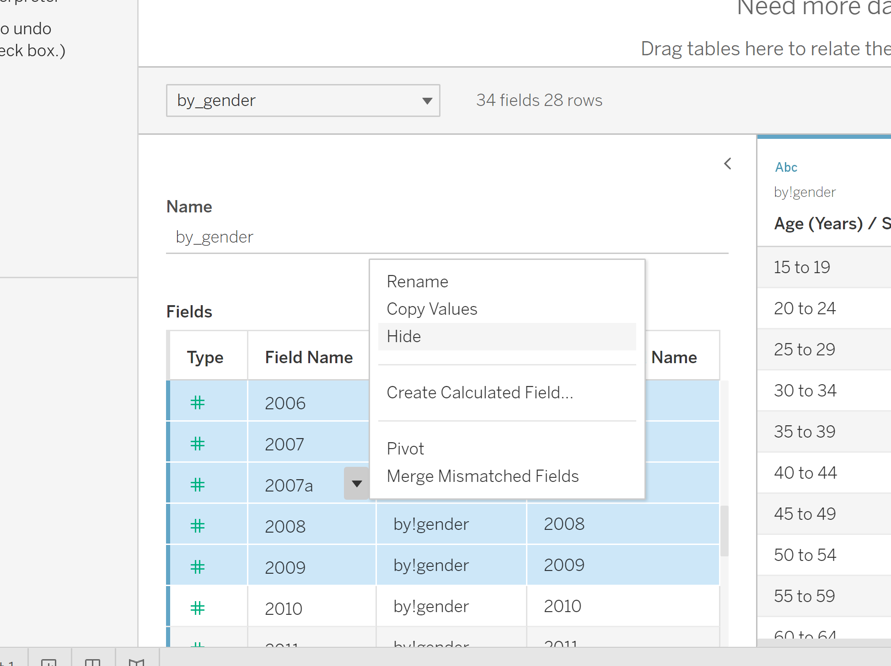

Import the excel file into Tableau and open ‘mrsd_Res_LEPR_2’ by dragging it onto the ‘ ‘.

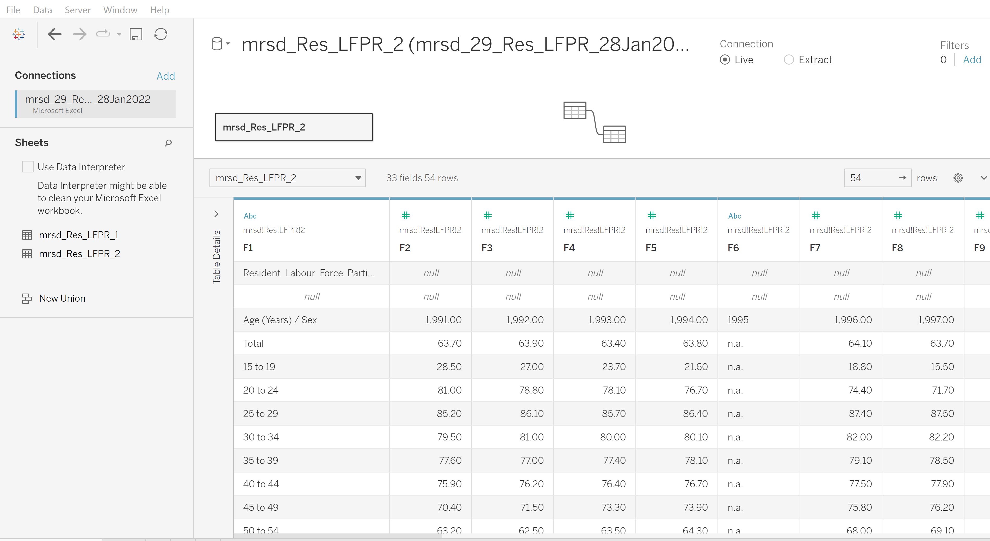

As the data is not in a cleaned and standardized format, click on ‘Use Data Interpreter’ to do a basic cleaning of the data. Below shows the result. It can be observed that the columns names are changed to ‘Age(Years)/Sex’ and different year numbers from 1991 onwards.

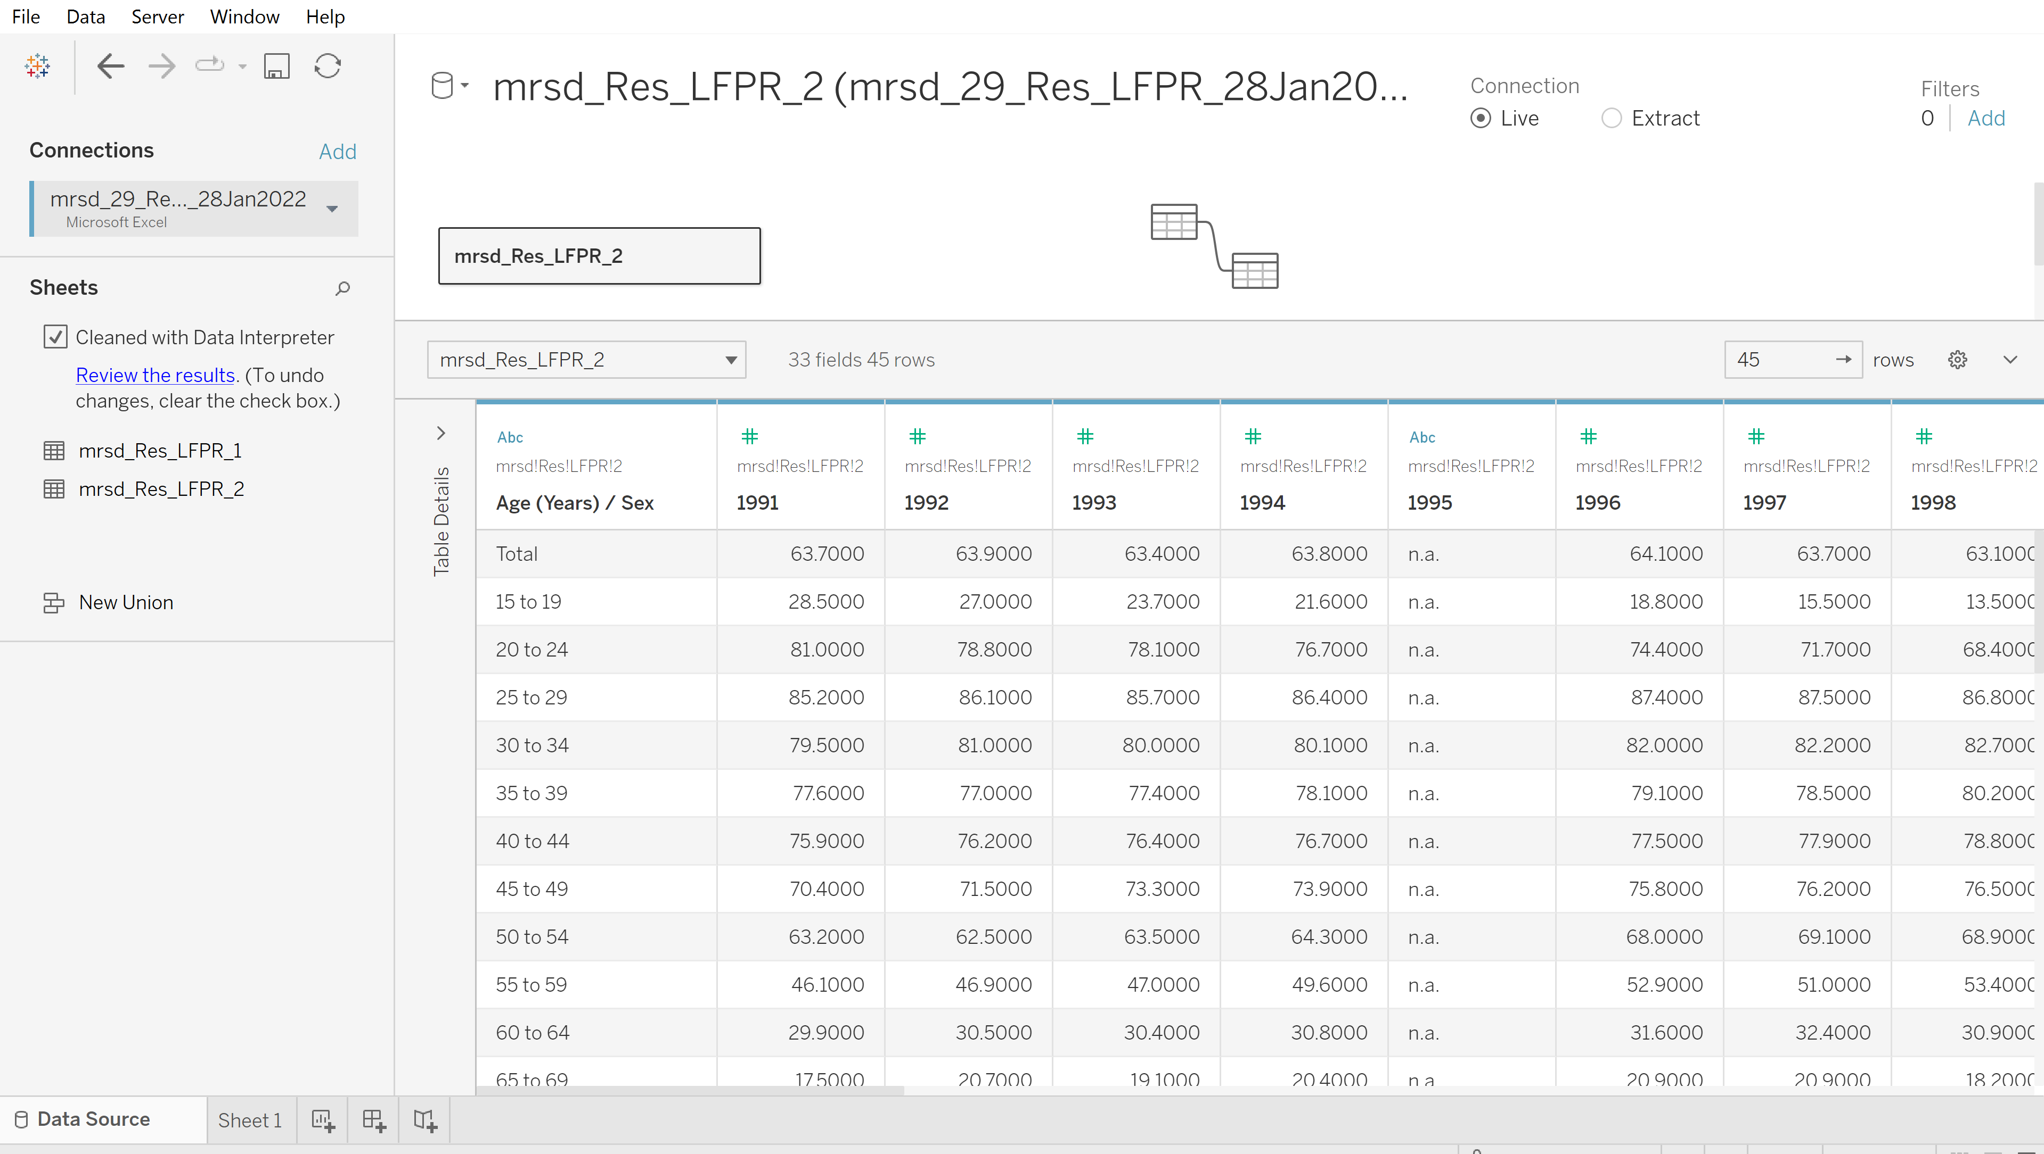

As the analysis only focuses on data for year 2010-2021, the data for year 1991 to 2014 can be removed by hiding it. This can be done simply by selecting column ‘1991’ under ‘Fields’ on the right, then press ‘shift’ key on the keyboard and select other years until 2009. The columns can then be hidden by right click and click on the ‘hide’ button.

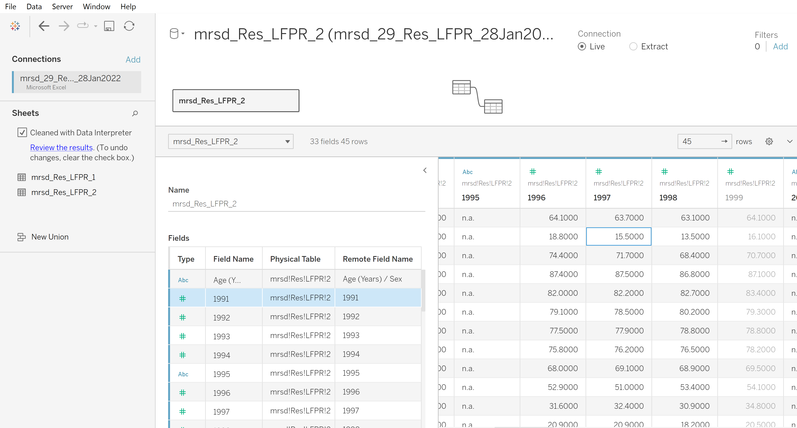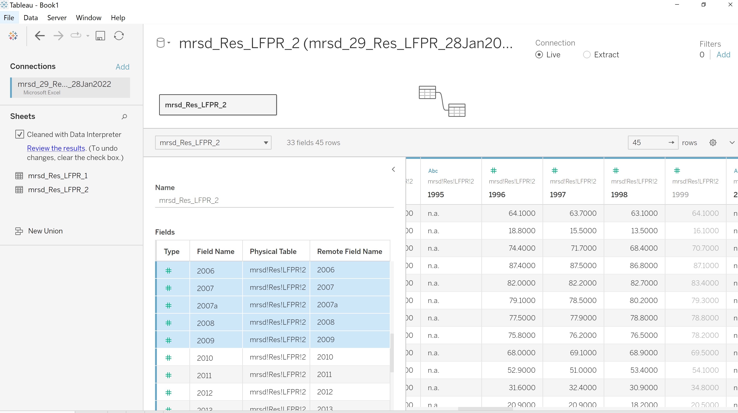

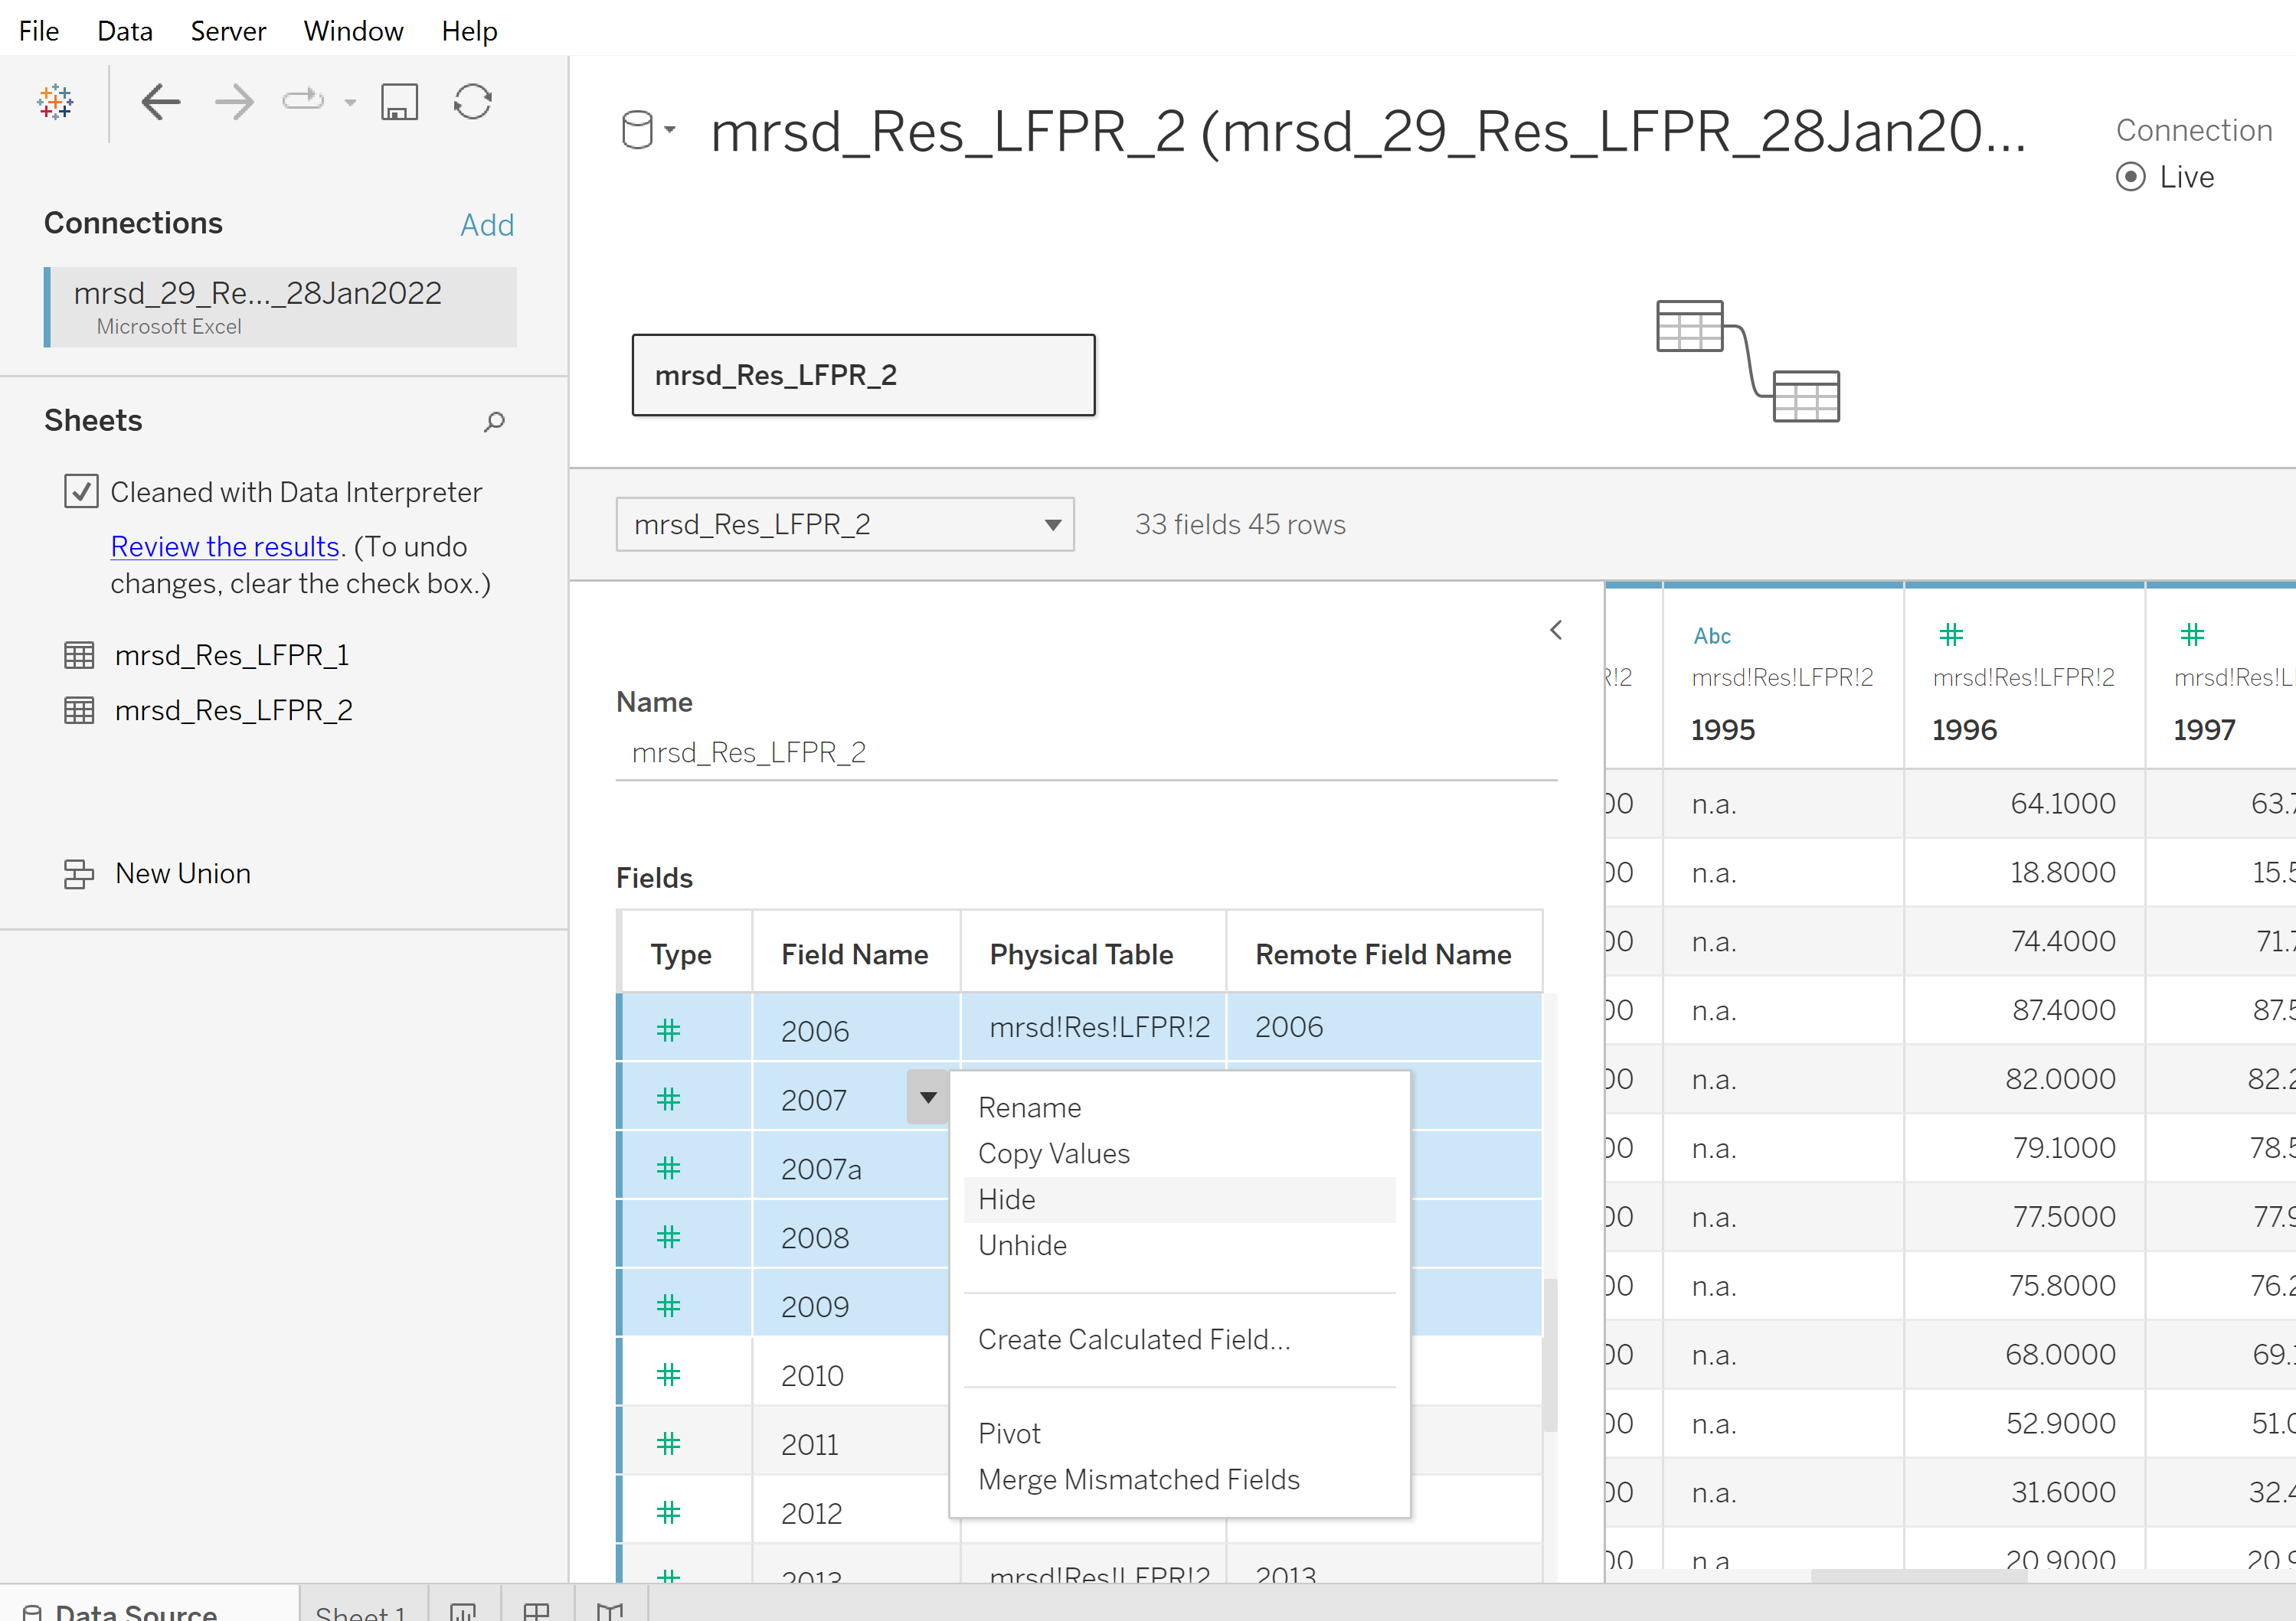

The columns hidden will be greyed out as shown on the right side, we can click on setting and uncheck ‘Show hidden fields’ to not shown these columns.

